IS MALE MORE DIFFICULT THAN FEMALE TO GET ADMITTED INTO TOP UNIVERSITIES

Xin Tang

Bellevue University

Abstract

In lieu of recent fair admission lawsuit against Harvard University's undergraduate admissions process, which is claimed to discriminate against Asian American applicants, There is another common impression in Asian community that males are more difficult to get admitted into top university than their female peers, this study is intended to validate if this is a true statement, by using data from top level universities, including those from Ivy Leagues and some other commonly acknowledged top schools.

Keywords: college admission, male, female.

GENDER FACTOR ON COLLEGE ADMISSION

# INTRODUCTION

Westwood high school, which my kids are attending, is the most competitive school in the city. Every year there are quite a few students who get admitted into Ivy school, or, if affordability is a concern, the top public university. In 2022, all top 10 have been admitted into the top 50 ranked US universities, including MIT and Harvard. Among these 10 students, Male to Female ratio is 6:3. This stands out when considering the male /female student ratio in this school is even. On the other hand, there is also a common impression that, due to gender balance/diversity concern, female students, who are at similar academic level and background, are more likely got admitted in than male students. From the neighborhood I lived in, I had heard 5 girls living close by got admission to top universities in 2022, but hardly heard any news related to boys. So, I am interested in exploring more on this topic. Meanwhile, I am only concerning the top universities since they are very selective, and the students enrolled are equally good.

## Questions to ask before research

To answer the question: “is male more difficult than woman to get admitted into top universities?” I need to turn the question into some more searchable questions. Here are a few questions I am trying to find answers:

* + Is there any google search in male/female admission?
  + Is there any search trend in gender-based admission discrimination?
  + What is the male to female ratio in Westwood high school?
  + What is the male/female undergraduate enrollment ratio in Harvard?
  + What is the national gender-based admission rate?
  + What are the data resources I can use?

## Preliminary findings:

Even though there are searches on gender factors on admission, there are many more searches on fair admission than gender factor. This could be an indication that gender may not be a common concern. At the same time, Harvard and several other top schools did admit more female student than male student in class 2026. At the same time, I come across an interesting finding that much more female student continue pursue the college degree than male. So, while female is dominating the undergraduate admission, this fact may not be due to discrimination or university intention, but due to some other factors, like more male students decide not to continue college education, but to start working after high school graduation. This needs to be explored more using more data and finding more facts.

References

Fair admission vs college admission gender search trend – Google trend.

<https://trends.google.com/trends/explore?date=today%205-y&geo=US&q=college%20admission%20gender,fair%20admission>

College admission gender search –Google trend

<https://trends.google.com/trends/explore?date=today%205-y&geo=US&q=college%20admission%20gender>

Harvard College Admits Class of 2026 (Mar-022) - The Harvard magazine

<https://www.harvardmagazine.com/2022/03/harvard-college-class-2026-admissions>#

Westwood high school 2022 top 10 (May-2022) - RoundRock ISD

<https://roundrockisd.org/graduation/top-10/whs-2022-top-10/>

How can Asian American male application standout in admission –Quora

<https://www.quora.com/How-can-an-Asian-American-male-applicant-stand-out-in-college-admissions>

immediate-enrollment-in-college-of-high-school-completers-in-the-us-by-gender

–statistica <https://www.statista.com/statistics/478663/immediate-enrollment-in-college-of-high-school-completers-in-the-us-by-gender/>

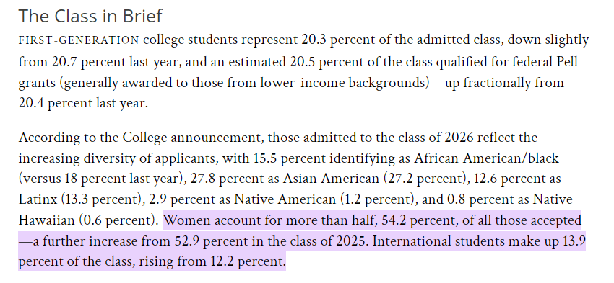

Figure 1. Harvard class 2026 admission diversity

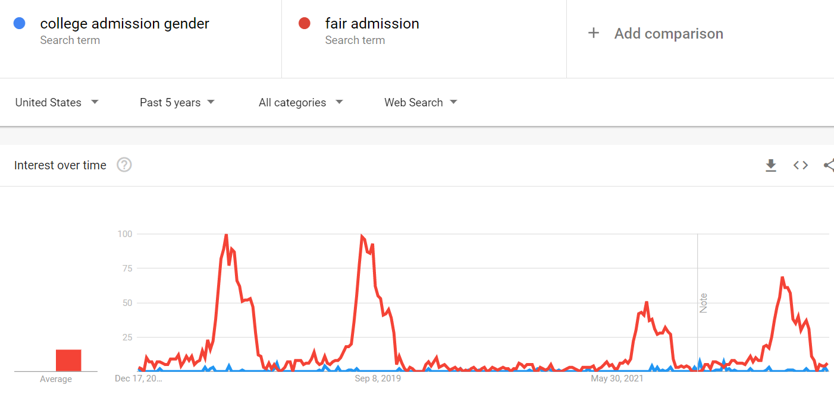

Figure 2. Google trend comparison between fair admission vs gender-based college admission

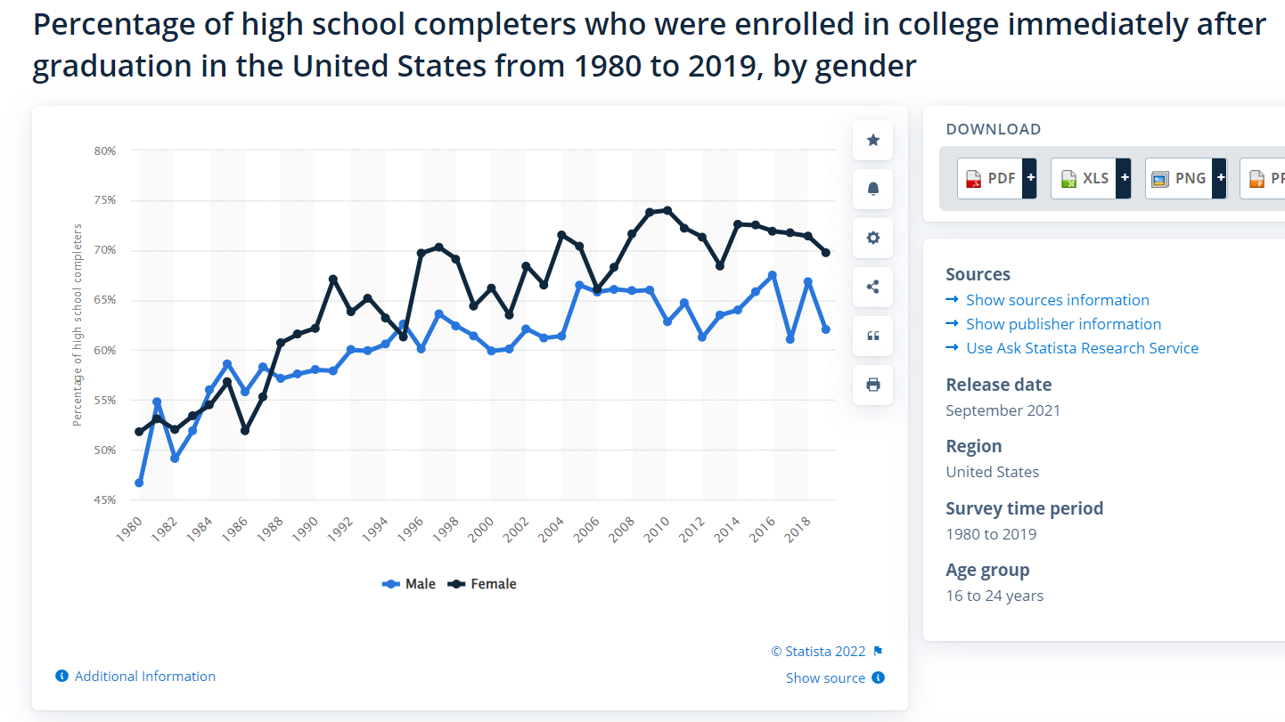

Figure 3. trend of high schooler who enrolled in college right after graduation, by gender